|  |  |
| --- | --- |
|  | **Airport Management**  **System**  **Technical Design Document**  **1.0** |
| |  |  |  |  | | --- | --- | --- | --- | |  | **Prepared By / Last Updated By** | **Reviewed By** | **Approved By** | | **Name** | Person 1 | Person 2 | Person 3 | | **Role** | Team Member | Team Member | Scrum Master | | **Signature** |  |  |  | | **Date** |  |  |  | |
|  |

Table of Contents

1.0 Introduction 3

1.1 Purpose of this document 3

1.2 Scope 3

1.3 Intended Audience 3

1.4 Definition & Acronyms 3

2.0 Conventions and Standards Followed 4

3.0 Assumptions, Dependencies and Risks 4

3.1 Assumptions: 4

3.2 Dependencies: 4

4.0 Schematic Diagram 4

5.0 Use Case Realization 5

5.1.1 User Registration 5

a. Functional Requirement 6

b. UI Validations 6

c. UI Controls 7

d. UI Methods Definition 8

e. UI Design 9

6.0 Database Design 10

6.1 Data Model 10

6.2 Tables Structure 10

7.0 Change Log 13

# Introduction

## Purpose of this document

The purpose of the detail design document is to define the detailed design for all the components of Airport Management System that are specified in the Business Requirement/Use case document. All the low level components, interfaces and integrations are detailed out in this document.

## Scope

This sub-section shall state the scope of this detailed design document

* Create and maintain plane details
* Create and maintain pilot details
* Create and maintain hangar details and plane allotments

## Intended Audience

*The intended audience for this document are*

* Developers, testers, other associates in the project
* Technical lead, Scrum Master
* Product Owner

## Definition & Acronyms

|  |  |
| --- | --- |
| **Acronyms** | **Definitions** |
| AMS | Airport Management System |

# Conventions and Standards Followed

The modules under scope needs to adhere to the coding standards and guidelines



# Assumptions, Dependencies and Risks

## Assumptions:

* Only one plane can be allotted to one hangar.
* The contact number and alternate contact number are unique throughout the User records.
* Plane scheduling is not implemented yet, so Pilot entity is not yet useful.
* One owner can have only one plane, so the owner is unique throughout the plane records.

## Dependencies:

* Availability of database design characteristics & access shall be defined by the
* Resource availability throughout each of the sprint

# Schematic Diagram

A schematic, or schematic diagram, is a representation of the elements of a [system](https://en.wikipedia.org/wiki/System) using abstract, graphic [symbols](https://en.wikipedia.org/wiki/Symbol) rather than realistic pictures. It gives an overview of overall system

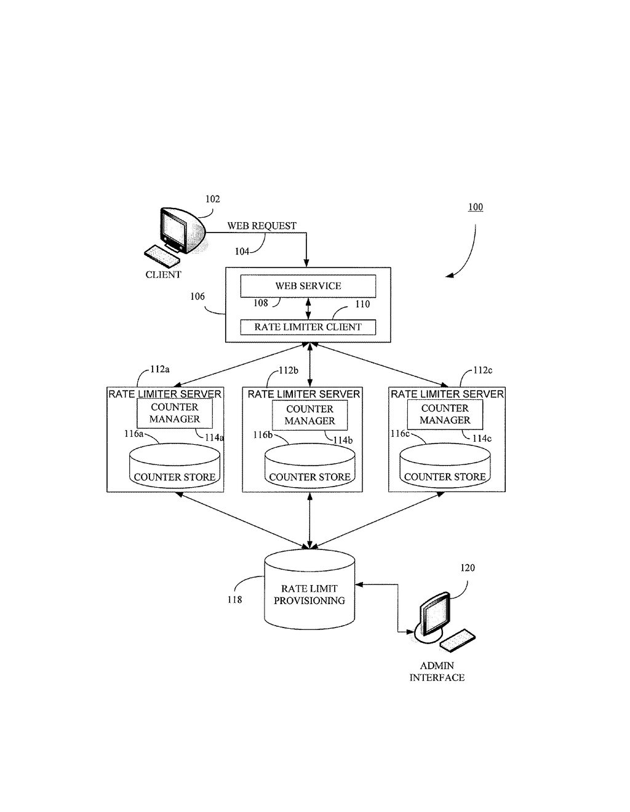

*The above pic is only an example and not representational of the Patient Health project*

# Use Case Realization

### User Registration

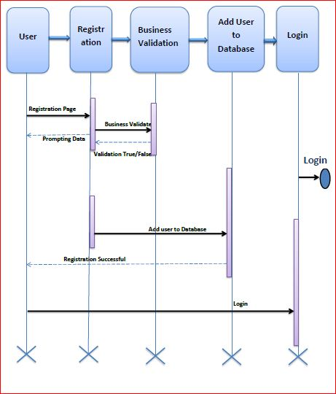

### Functional Requirement

. Login Page checks the authentication of the user and based on his role, directs the user to the respective page. User will provided with Add Patient, Details, Regulation and Search regulation pages and the same user will allowed to see Diagnosis Reports and patient vital parameters reports

### UI Validations

* User Id and Password fields are mandatory.
* Invalid User Id and / or password should not allow the user to get into the system

### UI Controls

|  |  |  |  |  |
| --- | --- | --- | --- | --- |
| **#** | **UI Component** | **Type** | **Name** | **Details** |
| **1** | User Id | Label | label_For_User_Id |  |
| 2 | User | Text field | Textfield_user | To enter username |
| 3 | password | Label | Label_for_password |  |
| 4 | password | Text field | Textfield_password | To enter password |

### UI Methods Definition

|  |  |  |
| --- | --- | --- |
| **Method Name** | **Parameter** | **Details** |
| SignButton_Click | object sender, EventArgs e | Allows the user to login into the portal and register the patient. |
| ResetButton_Click | object sender, EventArgs e | Clears the details entered by the user. |
| HomeButton_Click | object sender, EventArgs e | Loads the Homepage after registration is done successfully. |
| RegisterButton_Click | object sender, EventArgs e | Allows the user to insert the User personal details |
| ResetButton_Click | object sender, EventArgs e | Resets all fields given by user. |
| Page_Load | None | None |
| BMICalculator_Button_Click | object sender, EventArgs e | Allows the user to calculate the BMI of Patient |
| GlucometerButton_Click | object sender, EventArgs e | Allows the user to calculate the Blood Glucose Level of Patient |
| BloodCountButton_Click | object sender, EventArgs e | Allows the user to calculate the Blood Count Details of Patient |
| BMI_SubmitButton_Click | object sender, EventArgs e | To store the details to the database |
| Glucometer_SubmitButton_Click | object sender, EventArgs e | To store the details to the database |
| BloodCount_Submit_Button_Click | object sender, EventArgs e | Stores all the details in the database |

### 

### UI Design

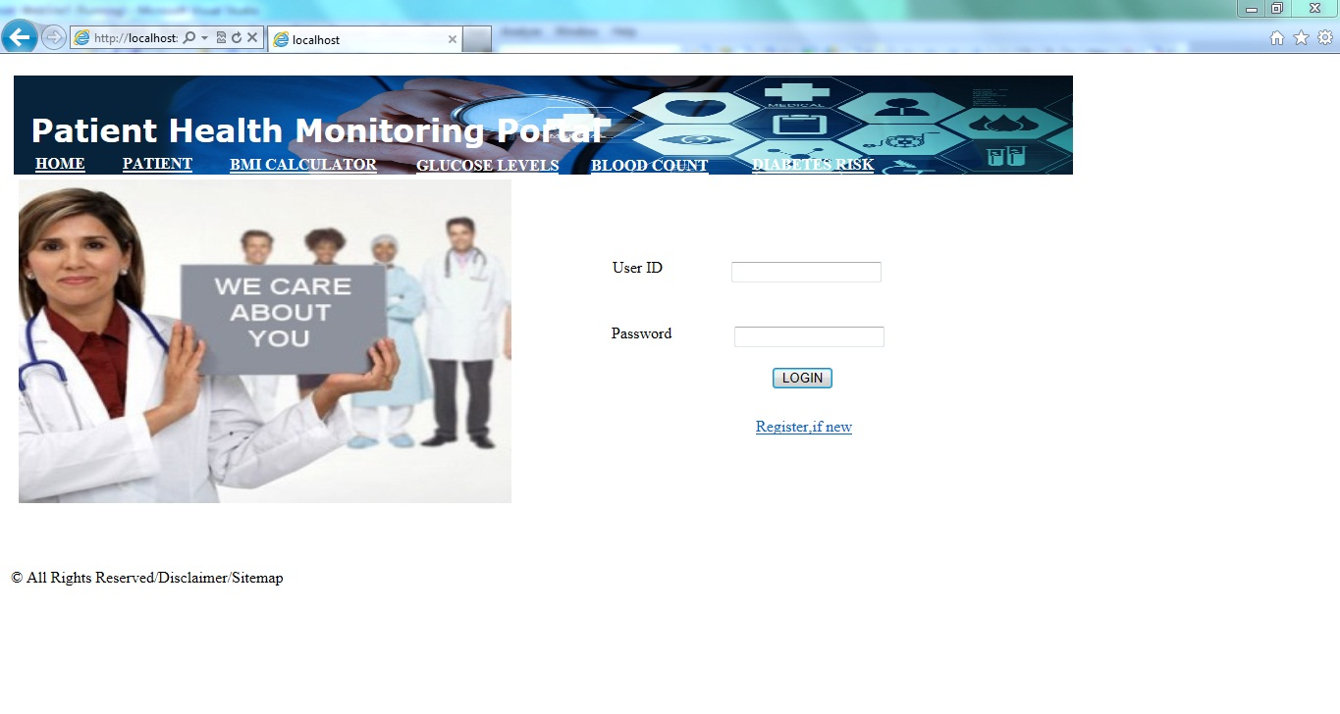

# Database Design

## Data Model

### The following is a schematic view of the database design

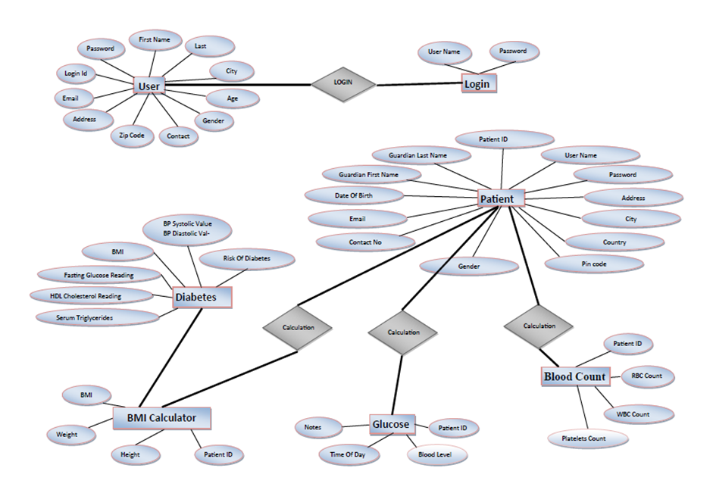

## Tables Structure

**User Registration:**

|  |  |  |  |
| --- | --- | --- | --- |
| **Column Name** | **Data Type** | **Length** | **Nulls** |
| Login Id | nvarchar | 50 | N |
| Password | nvarchar | 50 | N |
| First Name | nvarchar | 50 | N |
| Last Name | nvarchar | 50 | N |
| Age | int | 5 | N |
| Gender | varchar | 10 | N |
| Contact Number | varchar | 10 | N |
| Email | nvarchar | 50 | N |
| Address | nvarchar | 50 | N |
| Zipcode | nvarchar | 50 | N |
| City | nvarchar | 50 | N |
| State | nvarchar | 50 | N |

**User login:**

|  |  |  |  |
| --- | --- | --- | --- |
| **Column Name** | **Data Type** | **Length** | **Nulls** |
| User Id | nvarchar | 50 | N |
| Password | nvarchar | 50 | N |

**Patient Registration:**

|  |  |  |  |
| --- | --- | --- | --- |
| **Column Name** | **Data Type** | **Length** | **Nulls** |
| Patient Id | varchar | 10 | N |
| Username | nvarchar | 50 | N |
| Password | nvarchar | 50 | N |
| Date Of Birth | date |  | N |
| Email Address | nvarchar | 50 | Y |
| Contact Number | varchar | 10 | N |
| Address | nvarchar | 250 | N |
| City | nvarchar | 50 | N |
| Country | nvarchar | 50 | N |
| Pincode | varchar | 10 | N |
| Gender | varchar | 10 | N |
| Guardian First Name | nvarchar | 50 | N |
| Guardian Last Name | nvarchar | 50 | Y |

# Change Log

*Please note that this table needs to be maintained even if a Configuration Management tool is used.*

|  |  |  |  |  |
| --- | --- | --- | --- | --- |
| Version Number | Changes made | | | |
| V1.0 | *<First version>* | | | |
| V1.1 | *<If the change details are not explicitly documented in the table below, reference should be provided here>* | | | |
| Page no | Changed by | Effective date | Changes effected |
|  |  |  |  |
|  |  |  |  |
|  |  |  |  |
|  |  |  |  |
| V1.2 | *<If the change details are not explicitly documented in the table below, reference should be provided here>* | | | |
| Page no | Changed by | Effective date | Changes effected |
|  |  |  |  |
|  |  |  |  |
|  |  |  |  |
|  |  |  |  |

# 